NASA PACE satellite real-time update
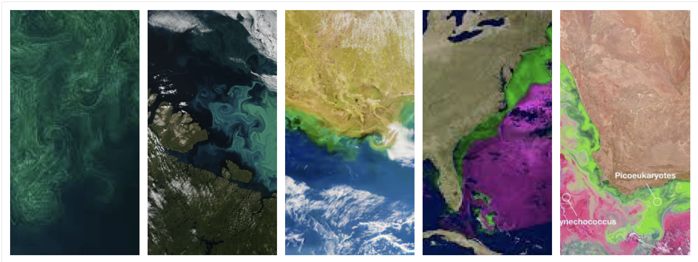
Enjoy the colors of the planet and watch how Plankton changes colours.

